Implementation and Timing of Insertion Sort and Merge Sort Algorithms

CS 303 HW 1

June 22, 2023

Trenton Davis
Problem Specification:
This project aimed to implement insertion sort and merge sort algorithms to sort variably sized arrays, to record the times taken for each algorithm to perform this task, and to compare the variation in the times based on the size of the array sorted. Several java programs were used to do this including a class that implemented the insertion sort algorithm, a class that implemented the merge sort algorithm, and a driver class that called each of the two proceeding algorithms on a number of variably sized arrays and recorded the times that each took to run for each array.

Program Design:
To achieve the steps listed above, three java classes were used. A class to implement an insertion sort algorithm, a class to implement a merge sort algorithm, and a class to implement a driver program that would call the sorting algorithms and time how long they took. Below is a breakdown of each class, its general methodology, and the methods that are employed within each.

Discussion of Algorithms:
The two sorting algorithms to be used in this project are insertion sort and merge sort. Insertion sort is a sequential algorithm that works by inserting a value from an array into a sorted array one at a time by comparing the element to be inserted with the rest of the elements and finding its correct place. It has a worst case time complexity of O(n^2). Merge sort works by continuously splitting an array into sub arrays and the sorting those sub arrays into a combined merged array working back up then from the smallest sub array to the top array. The time complexity of merge sort is O(nlogn) for all cases. These differences in variation in time complexity mean that insertion sort could beat merge sort for arrays that start out highly sorted, but its worst case time will almost always lose to merge sorts consistent time complexity.

Davis_Trenton_Lab01/02.java (Driver class):
This class served as the driver program to run the general flow of the analyses that were performed. This class contained a method called readArrFiles that would take in a directory path as an input and output a list of int arrays that corresponded to the arrays that were found in the .txt files found in that directory. The class also had a main method that would call the readArrFiles method with an input of the specific directory path where the files with the arrays to be tested were held. The main class then iterates through each array in the list finding and outputting the length of the array, calling the insertion sort and merge sort methods from their respective classes on the array, timing how long it takes each algorithm to sort the array, and outputting these times for analysis.

InsertSort.java:
This class serves to implement the insert sort algorithm. It has two static methods. The first is called implementAlg and does exactly as its name suggests implementing the insertion sort algorithm on an array that it takes as an input. The second method is called ensureSorted and it exists to check the correctness of a sorted array by iterating through the array and checking that each element is less than the element that comes after it.

MergeSort.java:
This class serves to implement the Merge sort algorithm. It has three static methods. The first is called mergeSort and it completes the part of the merge sort algorithm that splits the array to be sorted into smaller subarrays and recursively calls itself before reaching the smallest sized subarrays. It then calls the merge method. The merge method merges the two arrays that it is called on back into a larger array that is sorted. Finally, the ensureSorted method returns a boolean which is true if the array that it is called on is correctly sorted and false if it is not.

Testing Plan
Using the previously mentioned driver program, each of the classes implementing the insertion sort and merge sort algorithms were tested on a range of unsorted arrays. These arrays are contained within .txt files that are stored in a directory that can be accessed by the algorithms.

Test Cases
The test cases used for the program were unsorted arrays of varying lengths that were held in text files. The lengths of the arrays along with the file that they were held in were in the following format:

1000 elements 1000.txt
2500 elements 2500.txt
5000 elements 5000.txt
10000 elements 10000.txt
25000 elements 25000.txt
50000 elements 50000.txt
100000 elements 100000.txt
250000 elements 250000.txt
500000 elements 500000.txt
1000000 elements 1000000.txt

Both the insertion sort and merge sort algorithms were used on each of these arrays, and each array following its sorting was verified to be correctly sorted. The times that each algorithm took to sort were recorded by printing to the terminal.
Analysis and Conclusions
Below in Figure 1 and Figure 2, the times taken for each algorithm to sort the arrays of different sizes are shown.

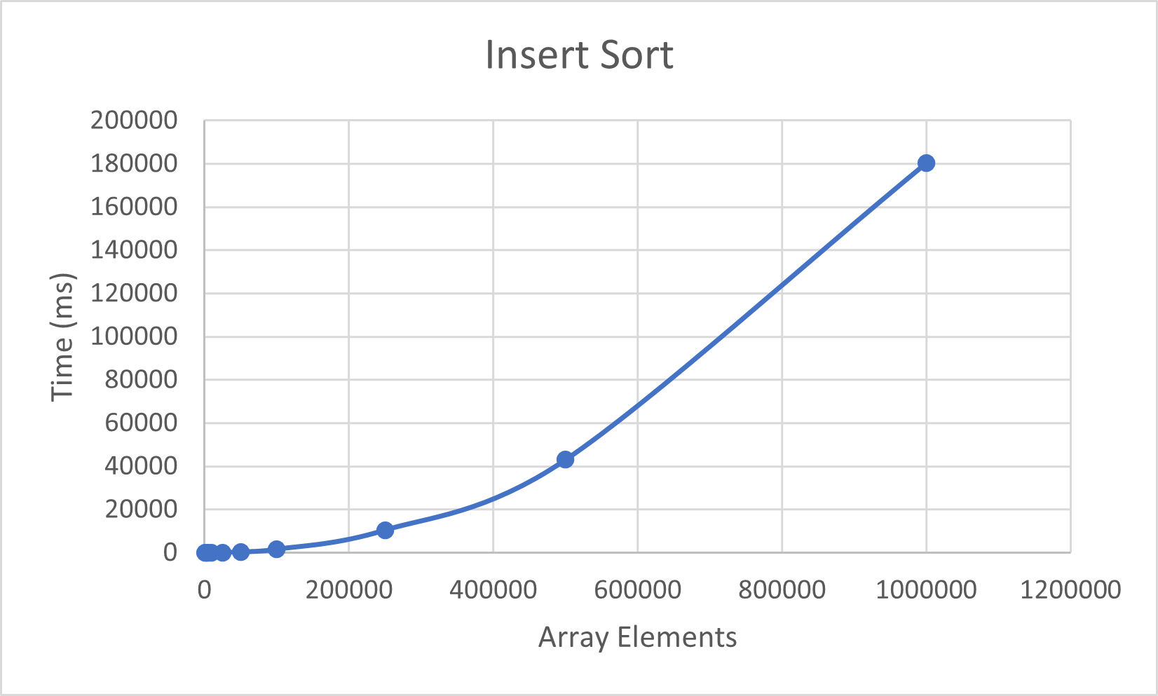Figure 1: Time complexity of Insertion sort

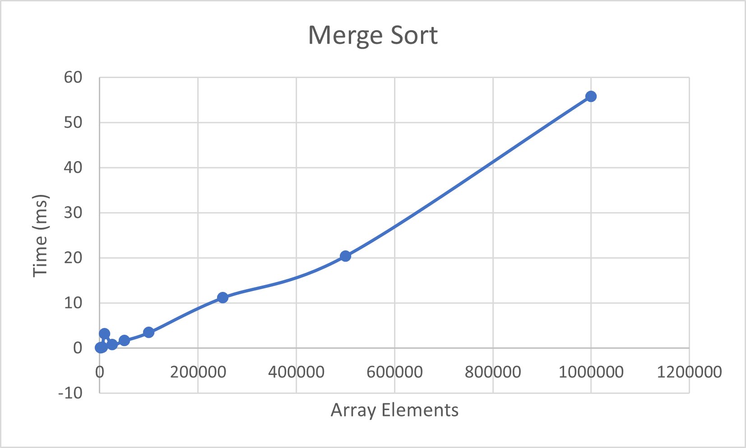Figure 2: Merge Sort time complexity

As can be seen in the figures, Merge sort consistently has better times for sorting the arrays than insertion sort does. These differences are even more pronounced. Both of the algorithms display the expected time complexities discussed above with insertion sort having a worst and average case of O(n^2) and the merge sort having a average, best, and worst case of O(nlogn).

References
APA (4th ed.) Citation: Cormen, T. H., Leiserson, C. E., & Rivest, R. L. (1990). Introduction to algorithms. MIT Press; McGraw-Hill.

